Using limit-cycle analysis to predicting the maximum possible vortex-induced-vibration translations and stresses in luminaire poles

Background: A large body of research examines vortex-induced vibration (VIV) of structures (beams, cables, and the like) subjected to fluid flow. Vortex shedding creates alternating pressures that cause vibrations that are limited by the damping. VIV is of concern in the fatigue design of luminaire poles. The fluid’s “ability” to vibrate the structure is a function of the mass of the fluid compared to the mass of the structure (mass ratio, M*), Strouhal number (S), and critical damping coefficient (ζ). There are many research papers that examine the possibility of a self-limiting behavior and equations that predict the maximum possible load effect. For example, Williamson and Govardhan (2004) in a seminal paper cites 150 studies in 42-pages their analysis of VIV behavior and limit-cycle amplitudes.
Empirical, analytical, and numerical methods illustrate an abrupt increase in amplitude (stresses) when certain non-dimensional parameters are below a well-defined threshold. Four examples are shown in Table 1. Different non-dimensional parameters are used for the x-axis and the load effect is represented on the y-axis. Note that log-scales are used in several plots. In all cases, there is a value which the load effect becomes relatively small (and acceptable to meet a particular fatigue detail CAFL resistance).
Design Implications: Current design procedures require fatigue design for high-mast poles greater than 55 ft. long. This limiting height is arbitrary and has no strong theoretical or empirical basis. Shorter poles may be non-conservatively neglected for VIV. Fatigue failure of shorter luminaire poles does occur and the current specifications do not address this as a limit state.
Research Objective: Develop a simple procedure to predict the maximum possible VIV load effect for luminaire poles and use this prediction for the design of fatigue critical details.
Work Tasks:
1. Review literature in the area of VIV for both aero-elastic and hydro-elastic research. Research will include: empirical studies, theoretical developments, and numerical methods.
2. Use the most promising methods to compare the prediction with load effects from Connor et al (2012). Figure 1 illustrates the load effect of one of the poles from this study plotted against the Skop-Griffin number. Actual observed data is shown from the study for eleven observation sites will be plotted on graphs to see how various methods predict field-based observations. One data point is illustrated. (NCHRP 718)
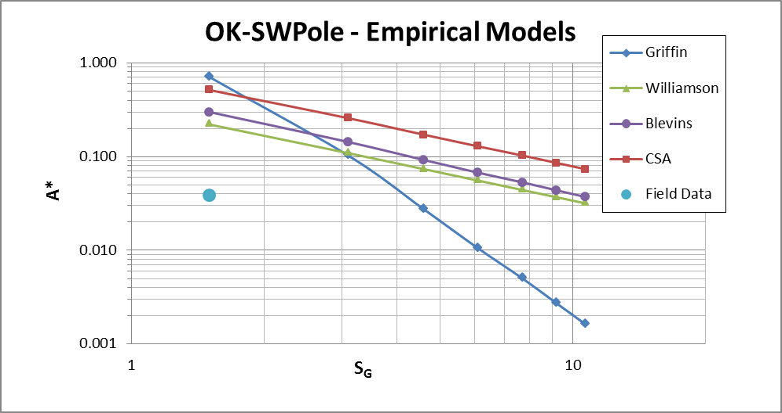
Figure 1. Various Simplified Approaches Using the Skop-Griffin Number (S_{G})
3. The promising models will be used to develop a simple equation to compute a non-dimensional parameter. If this parameter is less than a set value, then fatigue design is not necessary. Otherwise, fatigue design should be checked in the usual manner (AASHTO LTS).

Table 1. Examples of VIV Data (note rapid decrease in load effect after certain parametric values)
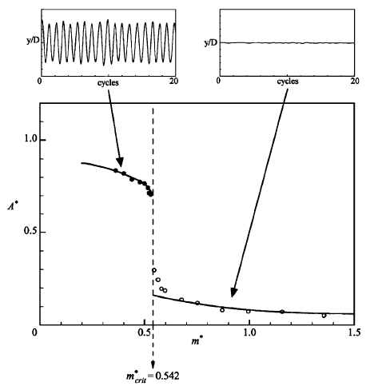 | 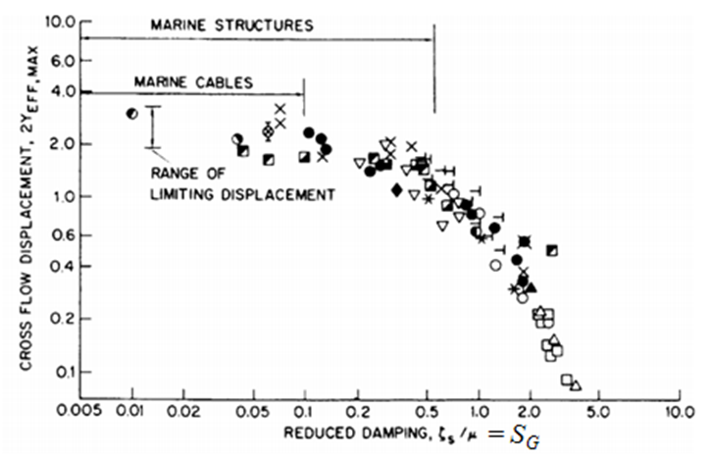
Discovery of a Critical Mass, Williamson and Govardhan (2004) | Griffin-Plot with Early Skop-Griffin Parameter (Griffin, 1980)
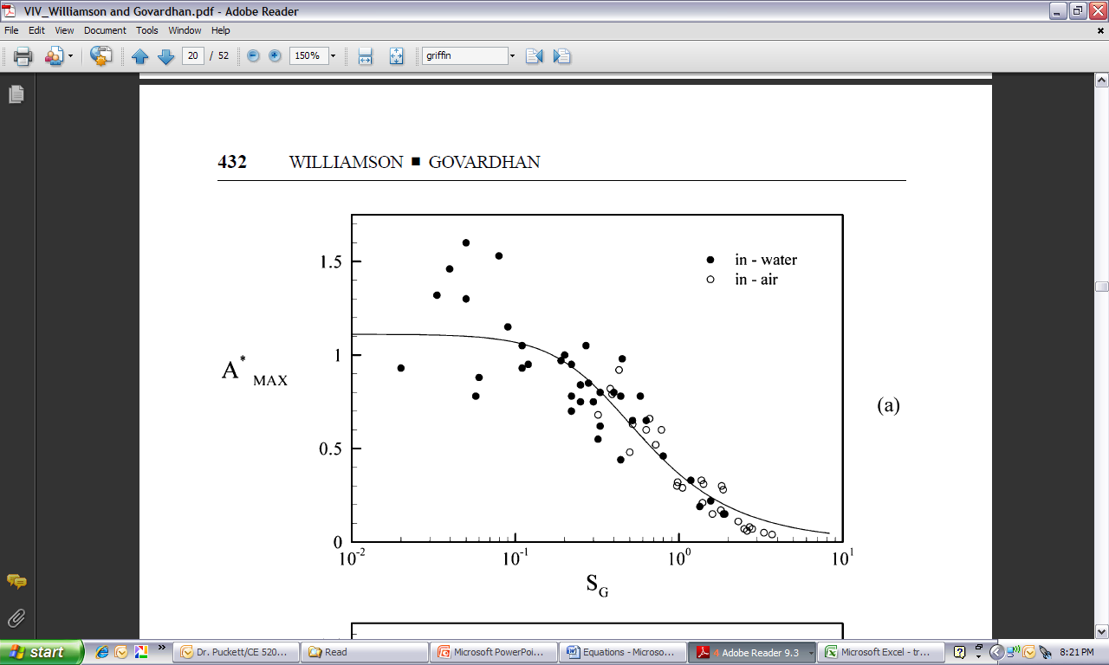 | 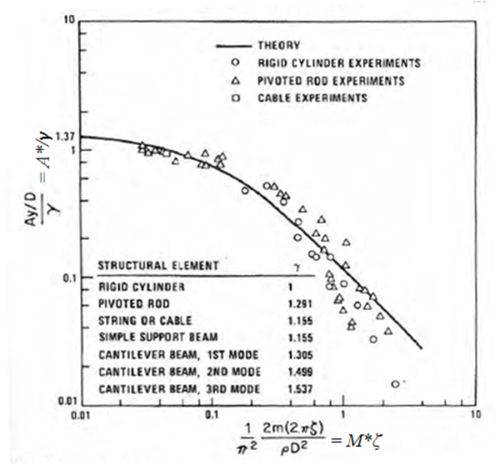
Griffin-Plot with Data (Williamson & Govardhan, 2004) | Maximum Amplitude of VIV as a function of Damping (Blevins, 1984)
Urgency: Poles under 55-ft fail and the specifications does not properly address (predict) this behavior.
Amount and Timeline: Project will take 18 months with two summers requiring $100,000.
Contact Information: Jay A. Puckett, PE, Ph.D., 307-760-5919, puckett@uwyo.edu, puckett@bridgetech-laramie.com
References
Blevins, R. (1984). Flow-Induced Vibration. Malibar, Florida: Kreiger.
Connor, R.J., S.H. Collicott, A.M. DeSchepper, R.J. Sherman, and J.A. Ocampo. (2012) Development of Fatigue Loading and Design Methodology for High-Mast Lighting Towers, NCHRP Report 718. Transportation Research Board, National Research Council, Washington DC.
Griffin, O. (1980). Vortex-Excited Cross-flow Vibrations of a Single Cylindrical Tube. ASME Journal of Pressure Vessel Technology, 102, 15866.
Griffin, O. (1984). Vibrations and Flow-Induced Forces Caused by Vortex Shedding. Washington, D.C.: Marine Technology Division, Naval Research Laboratory.
Williamson, C., & Govardhan, R. (2004). Vortex-Induced Vibrations. Annu. Rev. Fluid Mech., 413-55.

